* **Objective(s)**

1. To be familiar with syntax and structure of C-programming.
2. To understand the use of 'if else' and 'nested if else' loop along side 'switch case' condition.
3. To learn problem solving techniques with C.
4. To check for the errors in program and correct if any.

* **Program 1**
* To input electricity unit charge and calculate the total electricity bill according to the conditions.
* CODE

*#*include<stdio.h>

int main(){

int unit;

float amt,total_amt,sur_charge;

printf("Enter total units consumed: ");

scanf("%d",&unit);

if(unit<=50)

{

amt=unit*0.50;

}

else if(unit<=150)

{

amt=25+((unit-50)*0.75);

}

else if(unit<=250)

{

amt=100+((unit-150)*1.20);

}

else

{

amt=220+((unit-250)*1.50);

}

sur_charge=amt*0.20;

total_amt=amt+sur_charge;

printf("Electricity bill = RS. %.2f",total_amt);

return 0;

}

* **Output**

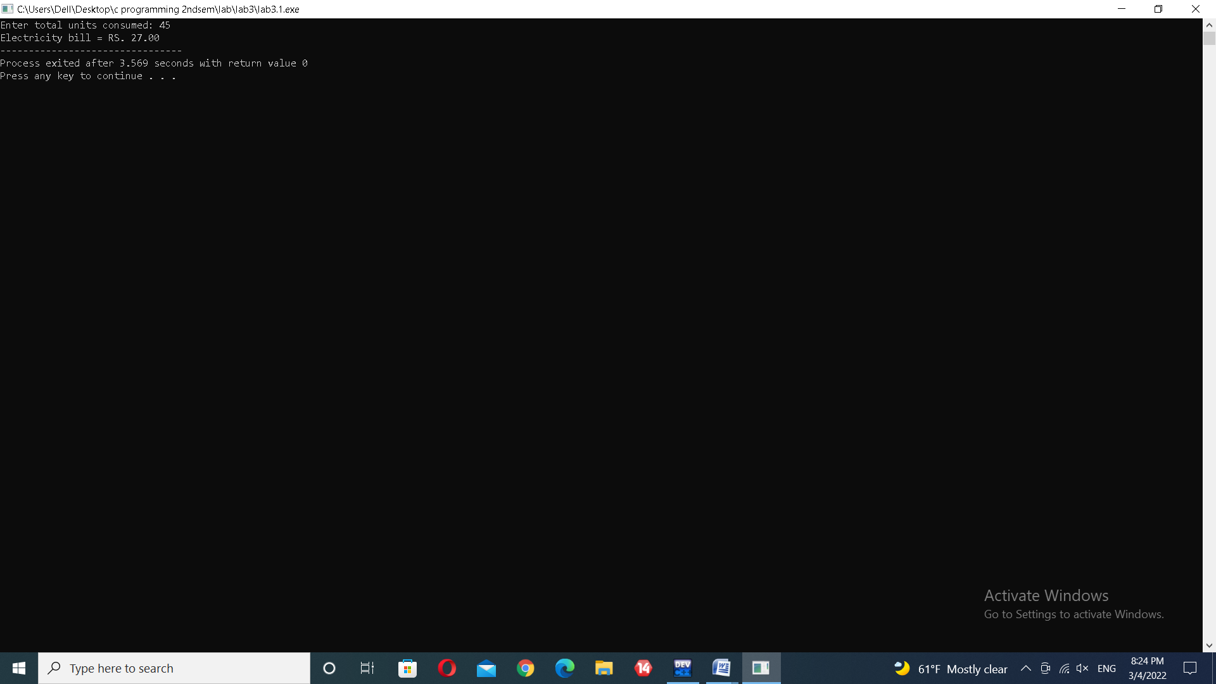

* **Program 2**

To correct the errors and find out the output of the program

* **Code 1**

#include<stdio.h>

int main(){

int n,i;

unsigned long long fact=1;

printf("Enter an integer: ");

scanf("%d",&n);

if(n<0)

printf("Error!Factorial of a negative number doesn't exist.");

else{

for(i=1;i<=n;++i){

fact*=i;

}

printf("Factorial of %d=%llu",n,fact);

}

return 0;

*}*

* **Output**

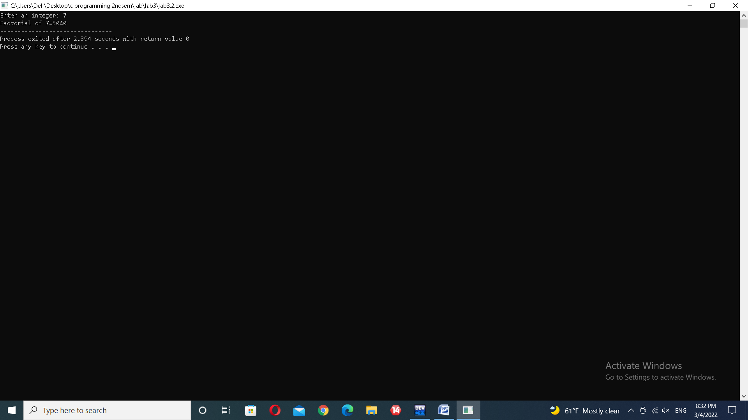

* **Code 2**

#include<stdio.h>

int main()

{

int week;

printf("Enter week number(1-7): \n");

scanf("%d",&week);

switch(week)

{

case 1:

printf("Sunday");

break;

case 2:

printf("Monday");

break;

case 3:

printf("Tuesday");

break;

case 4:

printf("Wednesday");

break;

case 5:

printf("Thursday");

break;

case 6:

printf("Friday");

break;

case 7:

printf("Saturday");

break;

default:

printf("Invalid input!Please enter week number between 1-7.");

}

return 0;

}

* **Output**

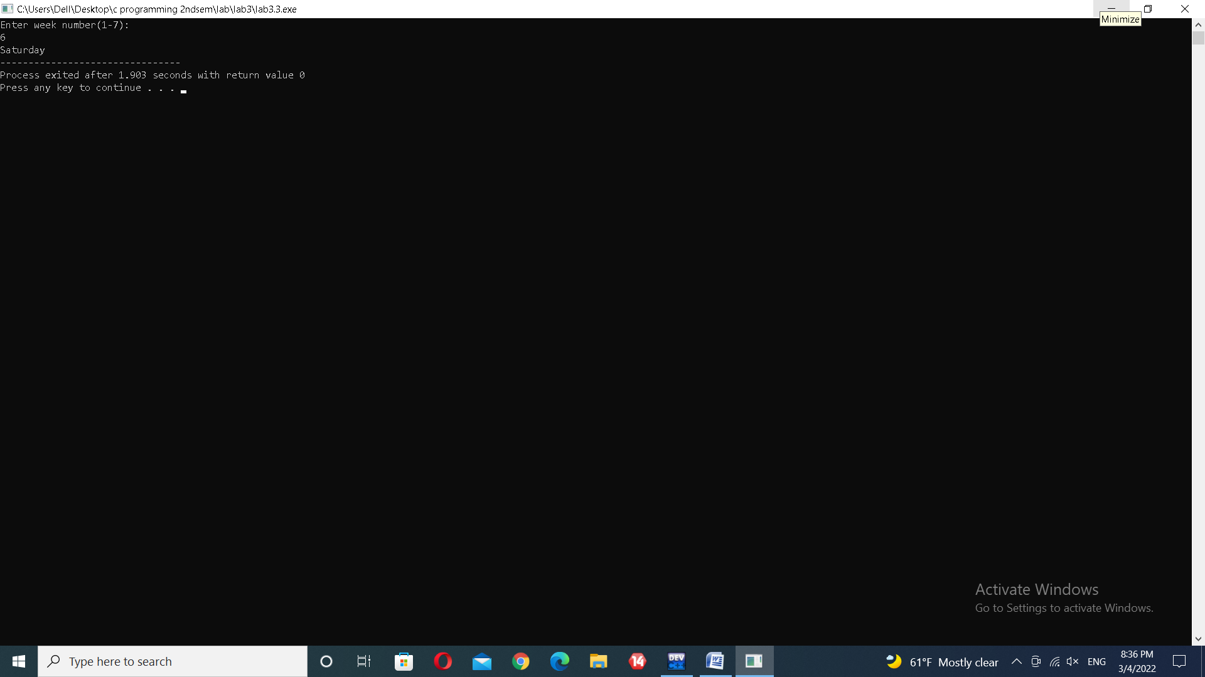

* **Program 3**
* To illustrate the concept of nested if else
* **Code**

#include<stdio.h>

int main(){

int age,num;

printf("Enter age:");

scanf("%d",&age);

if(age>=18){

printf("Enter number:");

scanf("%d",&num);

if(num<=100){

printf("you are valid voter");}}

else{

printf("you are not valid voter");}

return 0;

}

* **Output**

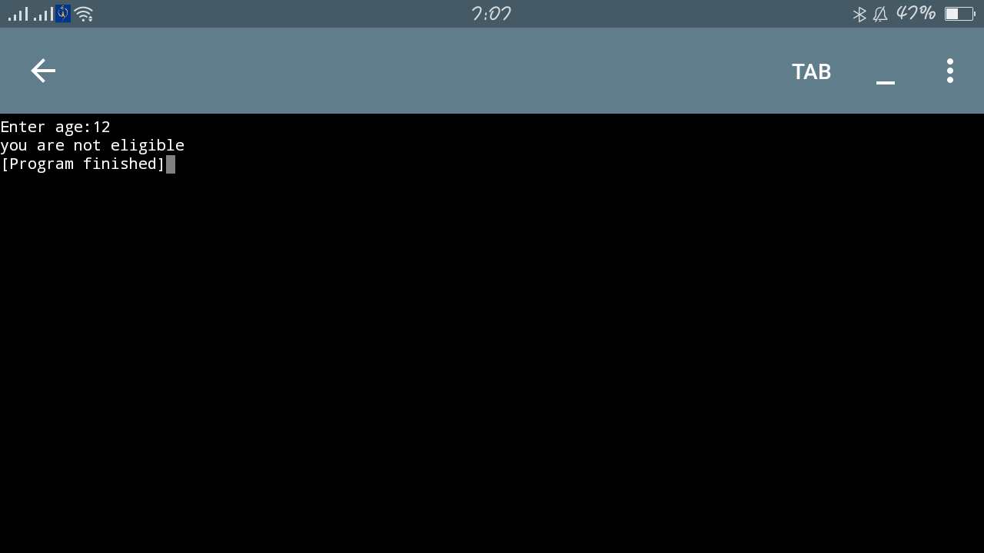

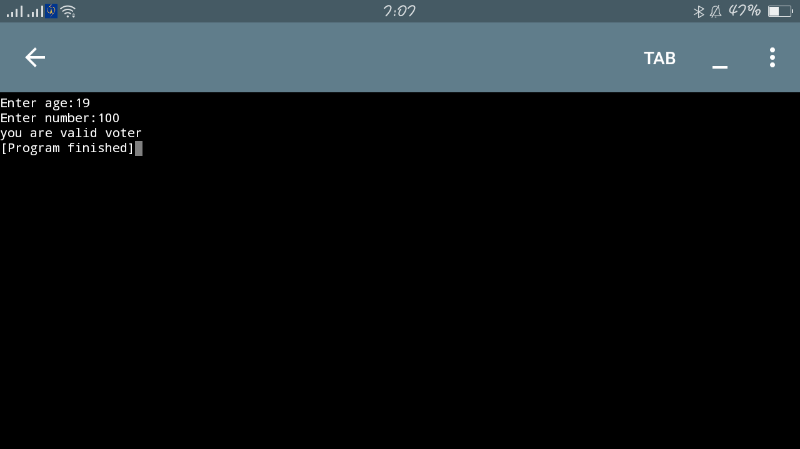

* **Discussion and Conclusion**

All of the codes were written and compiled in Dev C++.

In program 1, we calculated the electricity bill by entering the unit charges applying 'if…else if' condition.

Some errors were found during the execution of program 2. They are listed below:

* **Errors in code 1**

1. line 6: '%d' should be instead of '%f'
2. line 7: 'n>0' should be replaced by 'n<0'

* **Errors in code 2**

1. line 26: semicolon(;) should be used instead of comma(,)
2. line 12:semicolon(;) should be used instead of colon(:)

All of the above mentioned errors were corrected and the correct programs along with their outputs are written in the previous pages.

In program 3, we illustrated the concept of 'nested if else' condition by applying the condition to program a simple atm machine.

From this lab, we learned problem solving techniques and understood the use of 'if…else if' condition and 'nested if else' condition in C programming.